MOQ Tenant API Integration Process

1. Collect your credentials from MOQ IT Department. The following information must be ready prior to posting data through the API

* Username
* Password
* Bearer Token

1. Use Postman or any other utility to setup your request parameters.

Production url : <https://moq-solutions.com/api/postsales>

QA url : <https://moq-solutions.com/sandbox/postsales>

Type: POST

Header : {Username, Password, Token}

Data-Type : Application/Json

Data-Format :

[

{“Date”:”2020-10-26”, “Outlet” :”Mokarabia MOQ”, ”Revenue” : 30000}

]

**HEADERS SECTION**

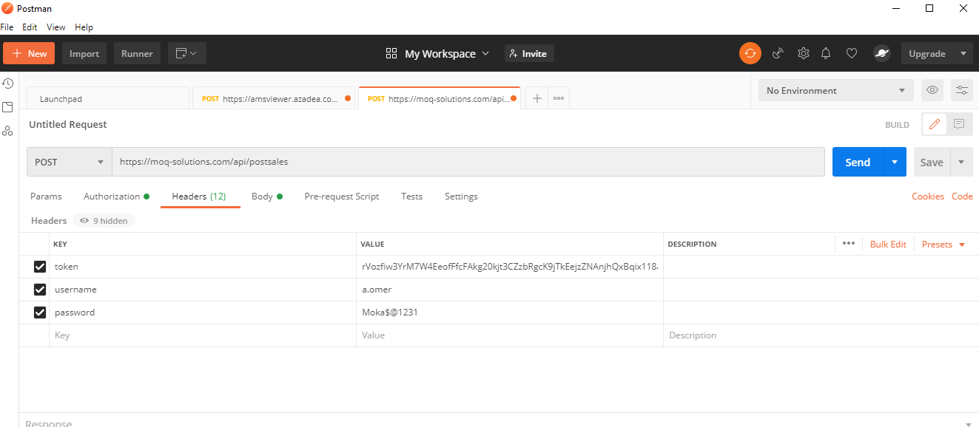

**BODY SECTION**

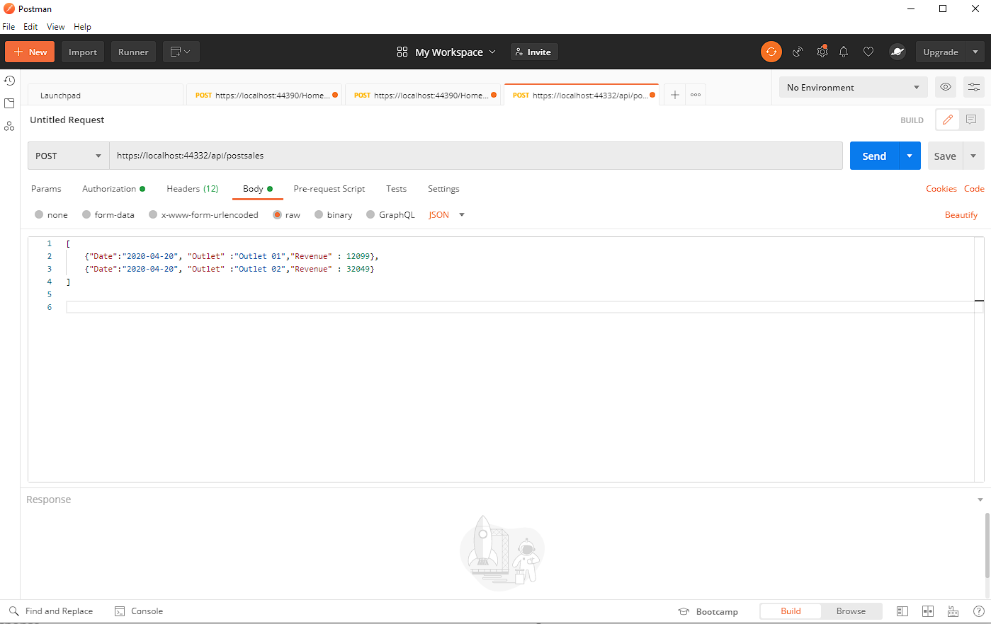

1. Upon successful request, you should get response of json format with **STATUS** as “**Posted**”



FAQ

1. What will be Http Status code after posting?

Http status code will be 200

1. What will be status code if any exception occurred at WebApi?

Http status code will be same as 200 but the response message json will be the change.

1. What if data does not post successfully?

Response json will empty

1. What if post data with invalid credentials?

Response json as follow

{

    "status": "Authentication Error. Please check your credentials and try again"

}

1. What if I get no response?

There might be issue with URL or json

1. What if I posted data other than json format?

You will be received http status code 415 (unsupported media type) and empty response json

END OF PROCESS

For any further assistance of query related to the API, please feel free to contact

**MOQ IT Department**

**2020**